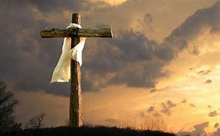

Good Friday worship service

Good Friday service will be held at the Nome Covenant Church on April 18th, 2025 at 7 pm. This will be a collaborative service between OSLC and four other local churches.