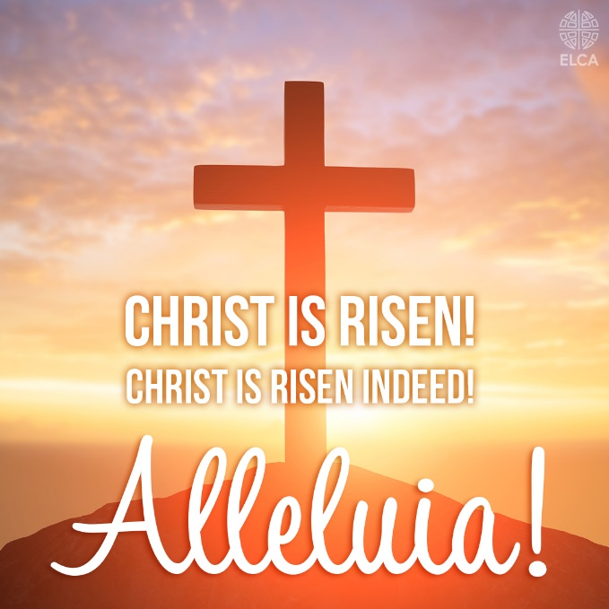

Easter Sunday worship service at Our Savior's Lutheran Church!

Please join us as we gather to celebrate the resurrection of our Lord Jesus Christ on Sunday April 20th, 2025.

OSLC will be hosting the Sunrise Easter Service at 7:00 am followed by a pancake breakfast in the Gathering Place.

Our regular Easter worship service will be held at 11:00 am.
Our Savior’s Lutheran Church gathers every Sunday at 11:00 am for worship services. Holy Communion is distributed at worship service on the first and third Sunday’s of each month.

We look forward to gathering with thanks and praise!

