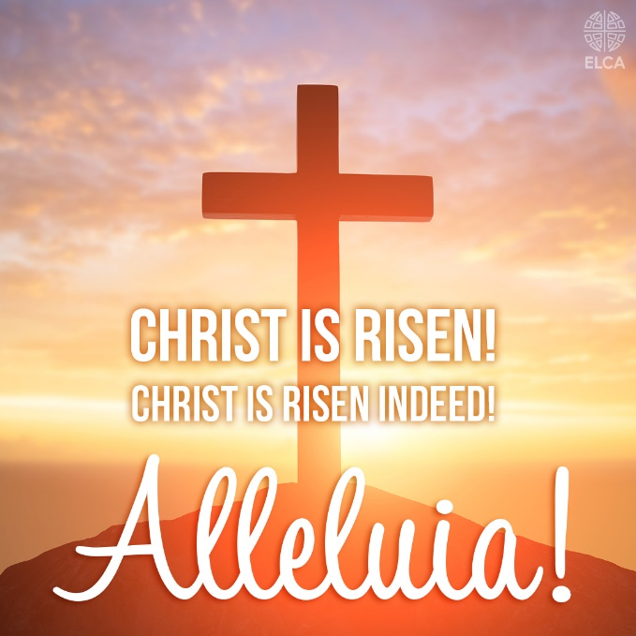

Easter Sunday worship service at Our Savior's Lutheran Church!

Please join us as we gather to celebrate the resurrection of our Savior’s Jesus Christ on Sunday March 31st, 2024. Worship begins at 11:00 am.
Our Savior’s Lutheran Church gathers every Sunday at 11:00 am for worship services. Holy Communion is distributed at worship service on the first Sunday of each month.

We look forward to gathering with thanks and praise!

