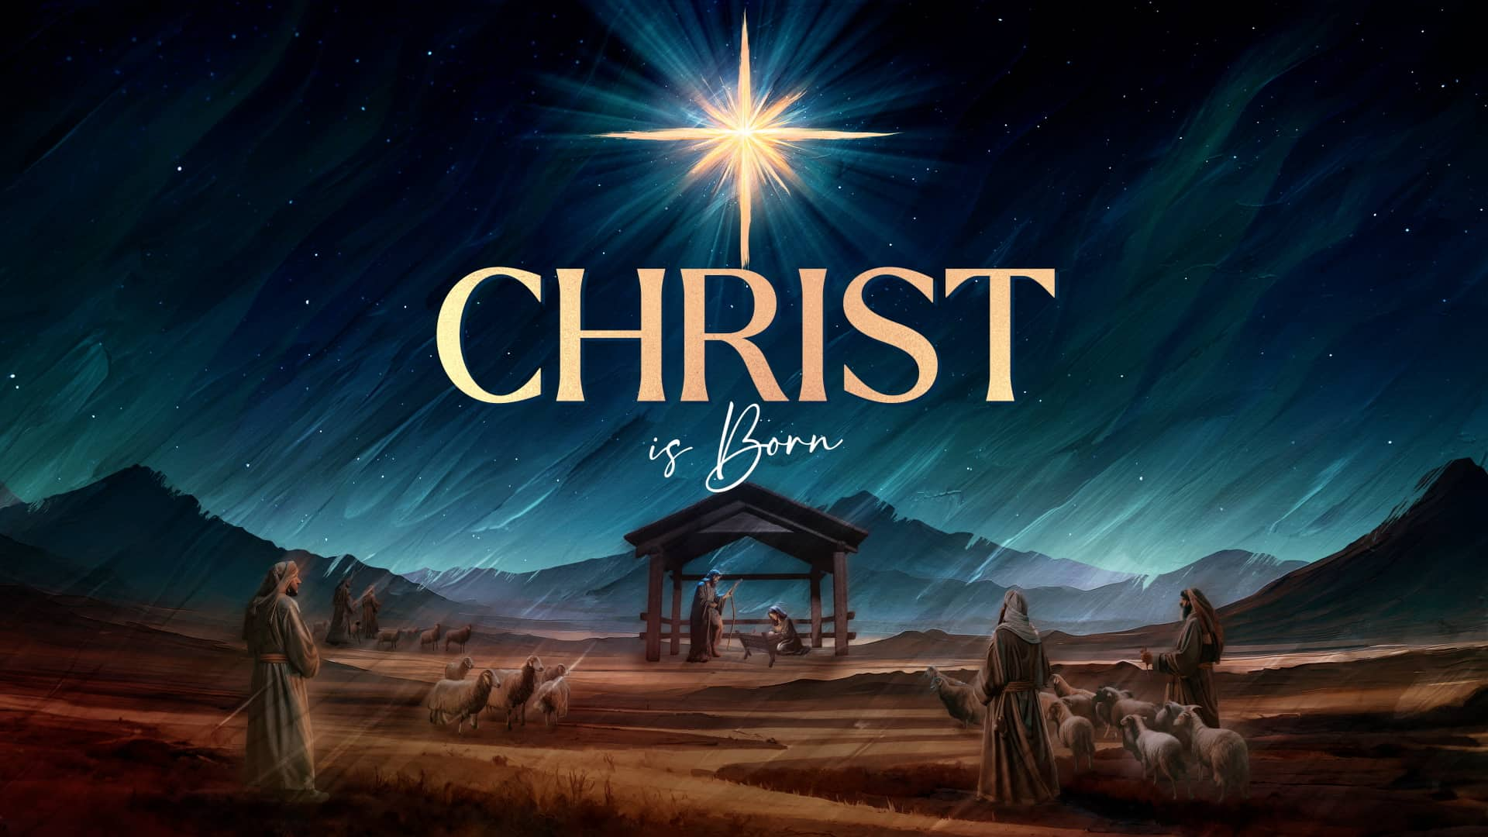

Christmas Eve Service
​
Christmas Eve service will be held at OSLC at 7:00 pm on Wednesday, December 24th, 2025. We would love for you to join us.

There will be no services on Christmas Day.

Merry Christmas to all

